Revenge Odyssey



**Session 2022** - **2026**

**Submitted by:**

Tayyaba Afzal 2022-CS-134

**Submitted To:**

Syed Muhammad Adeel

Department of Computer Science

**University of Engineering and Technology**

**Lahore, Pakistan.**

**Table of Contents**

Game Idea 3

Genre 3

Genre: 3

Sub-genres: 3

Art Style 3

Consistent Visual Elements Across Levels: 4

Art Style Variations by Level 4

Optimization for Mobile Platforms: 6

Background Story 6

Main Characters: 6

Narrative Flow: 8

Map Design 8

Start/End Points: 8

Map Elements: 8

Level Progression 8

Obstacles 9

Quest Triggers 9

Mechanics 9

Player Mechanics: 9

NPC Mechanics: 10

Team Coordination Mechanics (Realistic Focus) 11

UI Design (Mock Images) 11

Game Flow 12

Core Loop 13

## Game Idea

A team of vigilantes works together to seek justice for victims who cannot fight for themselves. The player controls different characters in each level, solving unique cases through teamwork, puzzle-solving, and action sequences. Inspired by the **K-drama "Taxi Driver,"** the game allows players to relive the tragic backstories of the characters and participate in intense missions for justice.

## Genre

### Genre:

* **Action-adventure:** The game focuses on both action sequences, such as combat and vehicle chases, and exploration, where players must navigate environments and interact with objects to progress.
* **Puzzle:** Players will need to solve various puzzles during missions, such as hacking systems, disabling security measures, and gathering clues.
* **Crime Thriller:** The narrative is based on criminal cases, where players act as vigilantes who deliver justice for wronged victims, creating tension and mystery as they uncover more about each case.

### Sub-genres:

* **Narrative-driven:** The storyline is a key element, with each mission and character background contributing to an overarching narrative that progresses with each level.
* **Team-based action:** Players control multiple characters, each with unique abilities, and work as a team to complete missions.

Art Style

The art style for our game is heavily inspired by the K-drama **"Taxi Driver"**, maintaining a **realistic** yet stylized look to reflect the gritty nature of the **revenge-driven** storyline. The focus is on immersive, cinematic visuals that blend the harsh reality of each mission with smooth gameplay optimized for mobile platforms.

### Consistent Visual Elements Across Levels:

#### The Deluxe Taxi:

* + At the start of every level, the iconic Deluxe Taxi makes its appearance, setting the tone for the revenge plot. The taxi is sleek, futuristic, and represents justice being served. Its polished exterior contrasts the grim scenarios faced throughout the game.

#### Character Cut-scenes:

* + Each player’s backstory is introduced with emotional cutscenes. These flashbacks, told with rich, realistic graphics, allow players to connect deeply with their characters’ motives. The lighting, colors, and angles in these scenes enhance the dark, revenge-filled narrative.

#### Team Planning:

* + The art style during team discussions emphasizes the strategic nature of the missions. The lighting is often dim, with detailed character expressions conveying the seriousness of the tasks. The setting is indoors, typically within the **BlueBird** **Foundation** office, with **dark wooden tables** and minimalistic furnishings.

#### Victim Rescue:

* + Kim Do Gi’s scene where he takes the victim to a **“gaming center”** is consistent across levels. The lighting is low and shadowy, with a heavy emphasis on suspense. The environment here is urban but sterile, reflecting the calculated nature of the team’s rescue missions.

### Art Style Variations by Level

The art style will vary depending on the tasks the characters perform, aligning with each level’s unique narrative and setting. The overall aesthetic remains realistic but adapts in tone and design according to the situation.

#### Level 1: Child Abuse (Elementary School)

* **Setting:** A school playground with a neglected atmosphere. Cracked walls, broken swings, and fading colors reflect the **distress faced** by the child. The environment contrasts the innocence of the playground with the serious undertones of child abuse.
* **Visual Tone:** Muted color palette, softer lighting to indicate the innocence of childhood, but with darker undertones to emphasize the harsh reality. The textures are detailed, with subtle hints of neglect like chipped paint and worn-out furniture.

#### Level 2: School Bullying (Middle School)

* **Setting:** A dimly lit classroom and hallway where bullying incidents occur. Desks overturned, papers scattered, and lockers slightly ajar reflect the chaos and fear in the environment.
* **Visual Tone:** The dark lighting and cool color scheme highlight the oppressive atmosphere of the bullying scene. The camera angles focus on the victim, making them appear isolated and vulnerable, while the bullies are often shown in groups to emphasize intimidation.

#### Level 3: Workplace Abuse (Corporate Office)

* **Setting:** A high-rise office with a sleek but cold corporate design. Cubicles, computers, and modern office furnishings dominate the environment. The character interactions emphasize the power dynamic between the abusive boss and the employee.
* **Visual Tone:** Sharp edges and clean lines reflect the sterile, uncaring nature of the workplace. The lighting is harsh and fluorescent, casting long shadows that emphasize the uncomfortable power dynamics.

#### Level 4: Financial Fraud (Bank/Financial Institution)

* **Setting:** A financial office or bank where fraudulent transactions are taking place. The environment is modern, with large computer screens, security cameras, and financial data displayed everywhere.
* **Visual Tone:** The lighting here is bright but tense, with the fraud happening behind the scenes. The color palette is cool with shades of blue and gray, reflecting the calculated and distant nature of cybercrime.

#### Level 5: Human Organ Trafficking (Warehouse)

* **Setting:** A dark, grim warehouse where illegal organ trade occurs. The environment is unsettling, with medical equipment, crates, and cold metallic surfaces. Some areas are dimly lit, with only small sources of light creating deep shadows.
* **Visual Tone:** Dark and foreboding, with the lighting and camera angles creating a sense of tension. The realism here is heightened, with detailed textures that give a grungy, dangerous feel to the space. The color palette consists of deep blacks, reds, and rusty metallic tones to create a sense of dread.

### Optimization for Mobile Platforms:

Despite the realistic and rich textures in each scene, the game will be optimized for mobile platforms by using low-poly models with detailed textures. This allows for high visual fidelity without overloading the hardware. Lighting and shadows will be carefully managed to ensure smooth performance while maintaining the immersive experience.

## Background Story

The game's narrative closely follows the team from ***Taxi Driver***, each of whom has a unique and tragic backstory. The game begins with a cinematic flashback for each character, revealing the personal tragedies that led them to join the **BlueBird Foundation**. These flashbacks will only be shown when the player assumes control of a specific character.

### Main Characters:

1. Kim Do Gi(Main Character)
   * **Role:** Main protagonist, skilled in hand-to-hand combat and driving the *Deluxe Taxi*.
   * **Backstory:** Kim Do Gi’s mother was brutally murdered by a serial killer, which left him scarred and seeking justice for others who have faced similar injustices.
   * **Gameplay Focus:** Driving action sequences and combat missions.
2. Ahn Go Eun (Tech Specialist)
   * **Role:** Tech specialist, handles surveillance, hacking, and information gathering.
   * **Backstory:** Go Eun’s older sister committed suicide after becoming a victim of an illegal spy cam incident. She now uses her skills to take down criminals who exploit others.
   * **Gameplay Focus:** Puzzle-solving and technical challenges, such as hacking systems to assist the team.
3. Choi Kyung Koo(Engineer)
   * **Role:** Engineer, responsible for maintaining the *Deluxe Taxi* and other technical operations.
   * **Backstory:** Kyung Koo has a strong moral compass and a deep connection to his team, acting as a fatherly figure despite his rough demeanor. He once had a promising engineering career, which was shattered by corrupt business dealings.
   * **Gameplay Focus:** Engineering tasks and support actions during missions.
4. Park Jin Eon(Mechanic)
   * **Role:** Mechanic, works closely with Kyung Koo in maintaining the vehicles and gadgets used in missions.
   * **Backstory:** He’s known for his cheerful personality but has a dark past that involved being exploited by his former employer. Jin Eon now seeks redemption through his work with the BlueBird Foundation.
   * **Gameplay Focus:** Support, minor combat, and assisting with vehicle maintenance.
5. Jang Sung Chul (Owner of BlueBird Foundation)
   * **Role:** The mysterious and charismatic leader of the BlueBird Foundation, Jang Sung Chul is a vigilante who seeks to avenge the victims who cannot find justice through legal means.
   * **Backstory:** Sung Chul witnessed many victims being failed by the justice system, which led him to form the BlueBird Foundation to help those who are wronged.
   * **Gameplay Role:** Jang Sung Chul only appears in cinematic cut scenes to brief the team on their missions and provide critical intel.

### Narrative Flow:

* Each mission starts with a cinematic flashback of the selected character’s background.
* Jang Sung Chul gives a briefing on the new case, which often relates to real-world issues like abuse, fraud, or exploitation.
* Players control different characters throughout the mission, each fulfilling their unique role in solving the case.
* After completing the mission, a cinematic shows the victim returning to normal life, or if the mission fails, the level restarts.

Map Design

Start/End Points: Each level starts with a cut scene briefing and ends with the mission’s resolution (either success or failure).

Map Elements: Urban environments such as city streets, alleys, corporate buildings, and hidden underground areas.

Level Progression**:**

* **Level 1 - Child Abuse** (School building, Classroom, Playground)**:**
  + A 10-year-old child is repeatedly abused by a teacher. The team must infiltrate the school and gather evidence.
* **Level 2 - School Bullying** (School yard, Streets, Bus stops)**:**
  + A high school student’s leg is broken by three bullies. The team must expose the school’s cover-up.
* **Level 3 - Workplace Abuse** (Corporate building, Office floors, Basement)**:**
  + An employee is harassed and abused by a higher-up. The team must sneak into the corporate office and find proof of wrongdoing.
* **Level 4 - Financial Fraud** (Bank, City alleys, Victim’s house)**:**
  + Innocent people’s bank accounts are drained by a corrupt financial advisor. The team must track the advisor and retrieve the money.
* **Level 5 - Human Organ Trafficking** (Hospital, Secret warehouse, Forest outskirts)**:**
  + A person’s son is killed, and the body is never found. The team uncovers an organ trafficking ring and must shut it down.

Obstacles**:** Security systems, locked doors, enemy NPCs, and environmental puzzles.

Quest Triggers**:** Completing puzzles or defeating enemies to unlock the next stage.

Mechanics

### Player Mechanics:

**Kim Do Gi (Main Character)**

* **Locomotion:** Fluid movement including running, crouching, vaulting, and driving.
* **Combat:** Tactical street fighting, using punches, kicks, grappling, and environmental objects. Focuses on disabling opponents quickly.
* **Special Mechanic:** Focused Takedown – Quietly eliminates enemies through chokeholds or critical strikes.

**Go Eun (Tech Specialist)**

* **Locomotion:** Stealth-based, avoiding enemies and using cover.
* **Puzzle-Solving:** Hacks systems via tools, solving puzzles or gathering codes.
* **Special Mechanic:** Real-Time Support – Provides tech assistance, disabling systems like traffic lights to aid teammates.

**Choi Kyung Koo (Engineer)**

* **Locomotion:** Slow and methodical, suited for heavy lifting.
* **Engineering Tasks:** Fixes vehicles and systems, grounded in real-world mechanics.
* **Special Mechanic:** Emergency Repairs – Performs quick fixes on vehicles or systems during critical moments, also distract target so that main character will perform its task easily.

**Park Jin Eon (Mechanic)**

* **Locomotion:** Agile, skilled in climbing and parkour.
* **Combat:** Limited hand-to-hand, focused on stealth to avoid combat.
* **Special Mechanic:** Quick Fix – Adds modifications to vehicles like better tires or minor repairs, also help Choi Kyung Koo to perform runtime task.

### NPC Mechanics:

* + **Enemy Types:** Thugs, corrupt officers, hired guards, and criminals. For example,
    - **Level 1:** The Abusive Teacher in Level 1, patrolling the school and alerting others if the player is spotted. The teacher wears a dark suit, reflecting a sense of control and power.
    - **Level 2:** A group of students who act as a gang, bullying a weaker child. Their behavior includes physically blocking the player’s path, throwing objects, and taunting them to create psychological pressure.
  + **AI Behavior:** Some enemies patrol fixed areas, others react to sound or visual cues.
  + **Ally NPCs:** The BlueBird Foundation owner who gives tasks and updates during missions. Jang Sung Chul remains a non-playable character (NPC) who directs the team from a distance

### Team Coordination Mechanics (Realistic Focus)

* **Real-Time Communication:** The team members communicate via realistic voice chat, phones, or radios. They give each other real-time updates on mission progress, enemy locations, or technical issues.
* **Strategic Gameplay:** Players must switch between team members based on realistic situations:
  + Go Eun hacks a system remotely while Kim Do Gi prepares for a physical confrontation.
  + Kyung Koo and Jin Eon modify or repair the taxi during missions when it takes damage.
  + Jin Eon scouts ahead, using his agility to access rooftops and hidden paths while the rest of the team handles main combat or exploration.
* **Mission Flow:** Each mission involves realistic goals and obstacles. For example, Kim Do Gi might have to extract a victim while avoiding police and enemy forces, with Go Eun feeding him critical intel from the security cameras

UI Design (Mock Images)

* **HUD:**
  + Mini-map (displays locations of objectives and enemies).
  + Health bars for players and important NPCs.
  + Task tracker for current objectives.
* **Menus:**
  + Main menu (start, options, level select).
  + Character selection (choose which team member to control for missions).
  + Dialogue boxes and prompts for mission briefings.
* **Inventory (if applicable):** Simple items like keys, puzzle pieces, or tools for specific tasks.

Game Flow

This flow chart is just general for each level.

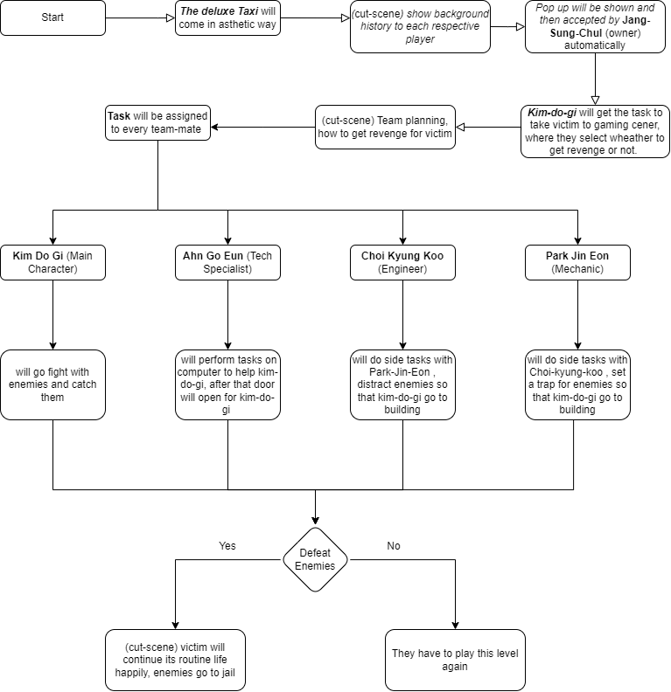

Core Loop

1. **Receive Mission:** The player starts by watching a cinematic introduction to the level.
2. **Plan:** Briefing scene where the team discusses the mission strategy.
3. **Play:** The player alternates between different characters, each with their own role.
4. **Overcome Obstacles:** Solving puzzles, defeating enemies, and avoiding traps.
5. **Mission Outcome:** Either the mission is completed successfully, and the victim is saved, or the player fails and must retry.